S.NO  Core Java problem statements | Problem Statement
1. | write a java program to build a class Employee having name, department, salary & performanceRating as attributes. And using Java Streams :  Filters the employees who have a performance rating of 4.0 or higher.  Find the highest paid employee after filtering.  Print the salary of the highest-paid employee with rating above 4.0 .
2. | Create a student class with roll number, name & address as data members, initialize and display student details.  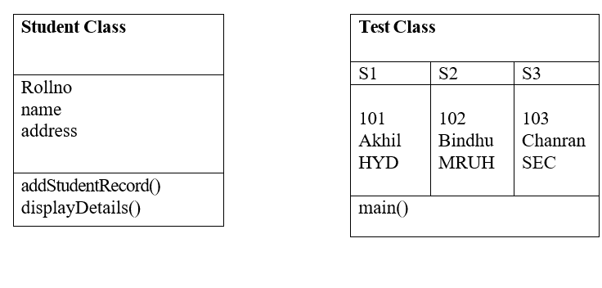
3. | How to copy an object in Java?
4. | Build java program for the following class structure.  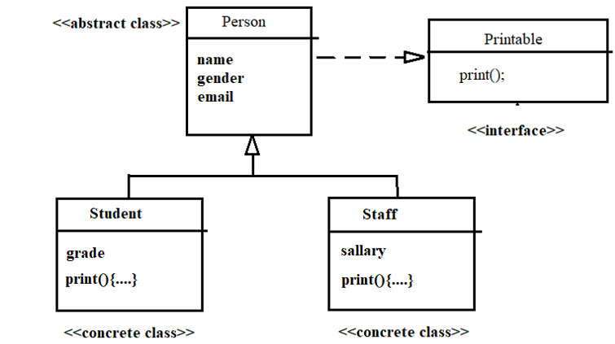
5. | Build java program for the following class structure.  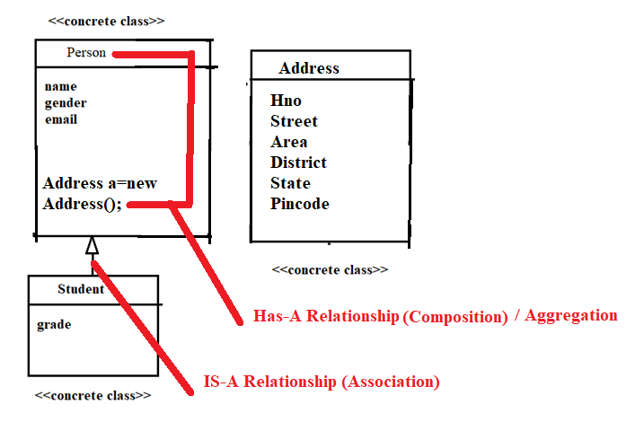
6. | Create a BankAccount class with an Inner class Interest implementing a scenario such that only an authenticated bank person can interact with inner class by calling contact() method of BankAccount. When contact() method will be called, it will verify with password and then he will be able to use the inner class and access it.
7. | A software development company is designing a library management system that requires a flexible data container to store different types of items, such as books, magazines, and DVDs. The company wants a generic class that can store any type of object
8. | Java Regular Expression Example: Email Validation
9. | For the Appilcation on International flight booking system, the system needs to calculate the arrival time of a flight based on:  - Departure time (Local Time Zone)  - Flight duration  - Destination time zone  Your task is to write a Java program that:  - Takes a departure time in one time zone.  - Adds the flight duration to determine the arrival time.  Converts the arrival time to the destination's time zone.
10. | Bank Account Withdrawal System with Custom Exceptions  Design a Java application to simulate a basic bank withdrawal system. The system must include robust error handling using user-defined exceptions to enforce business rules and ensure valid transactions.

